StormGeo Saved Searches Details

DF 9: Product Status Updation from NS to SF
[Celigo] Subscription Update:-
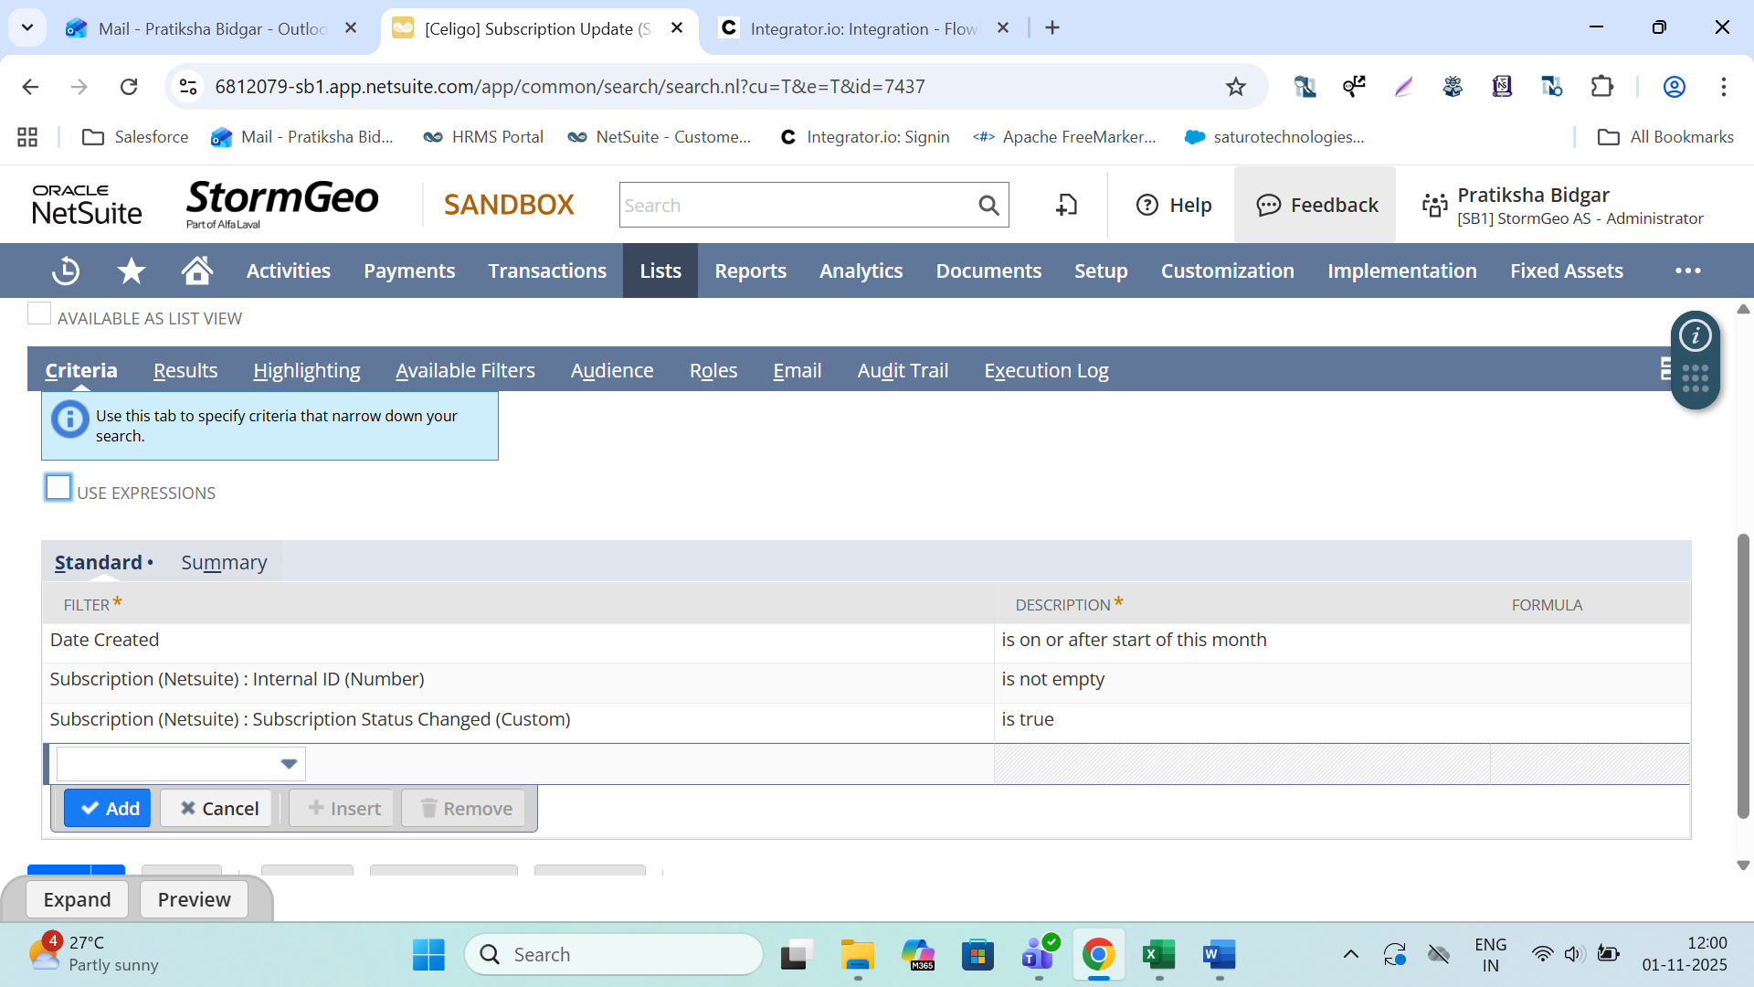
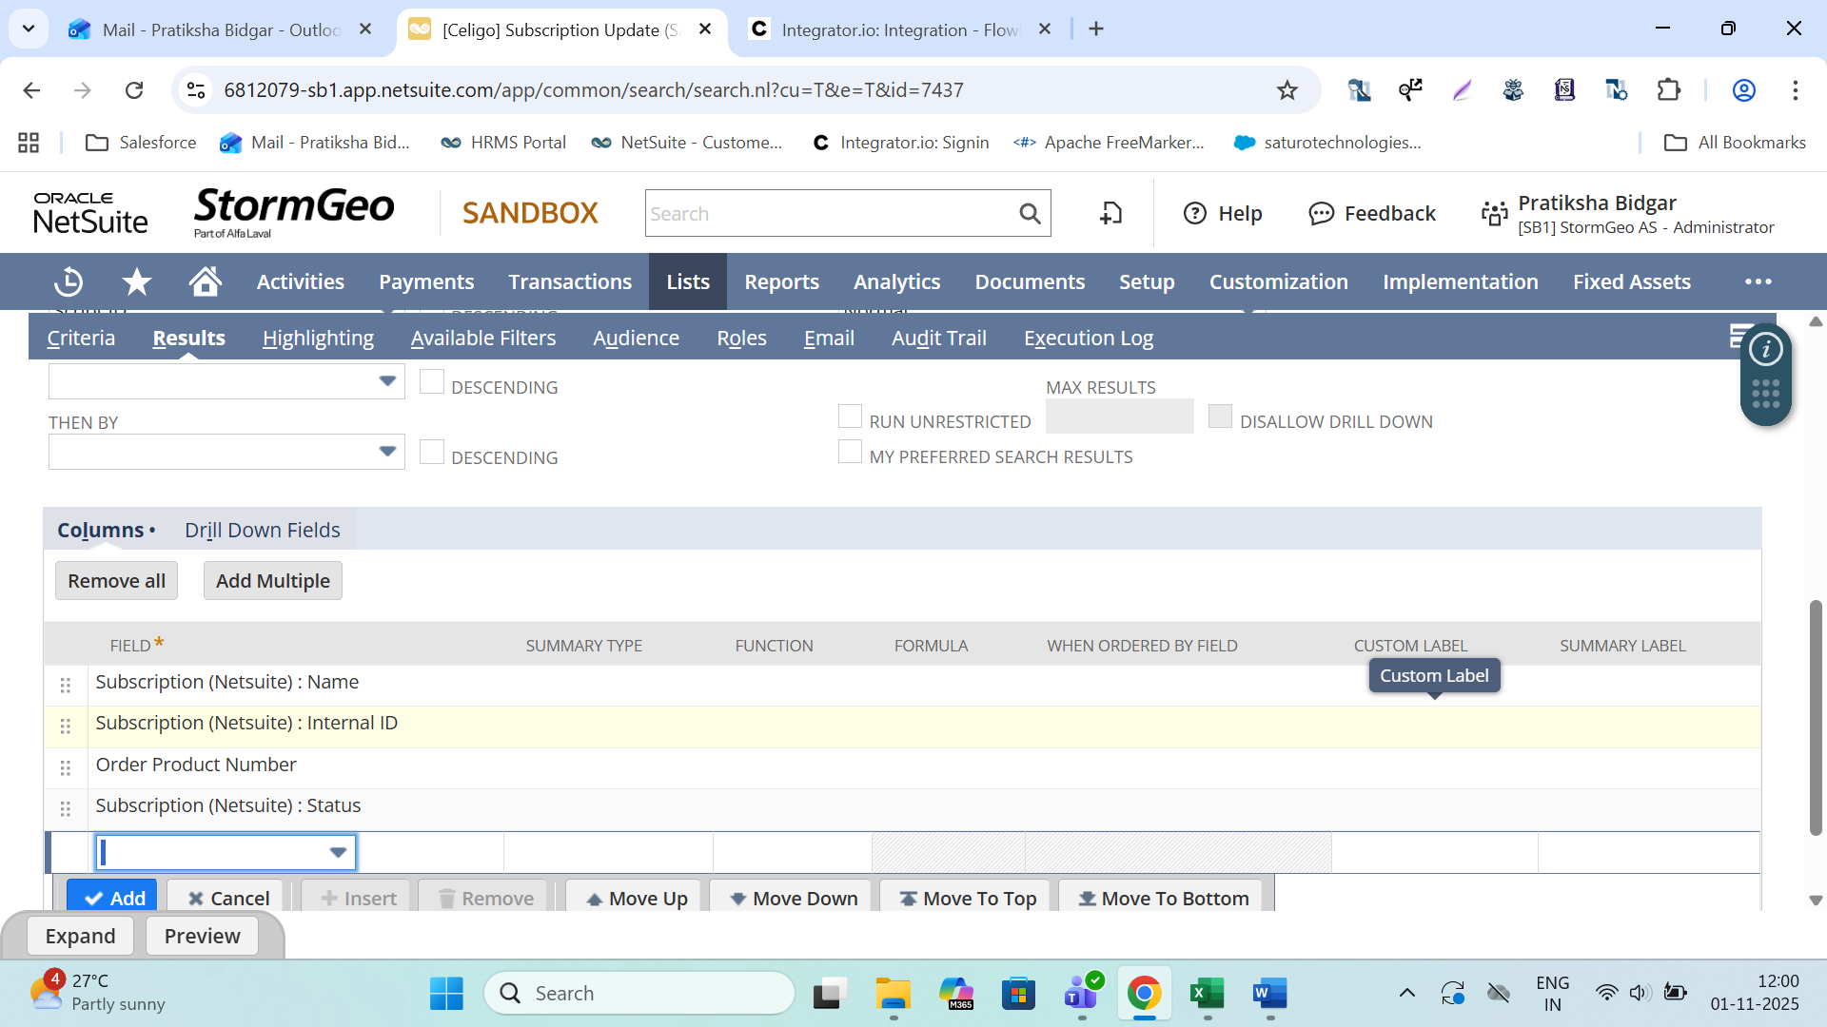
Working - DF6: Salesforce Usage Place Holder to NetSuite Usage Flow
1.Orders Products Sync. Search****PLEASE DON'T DELETE******
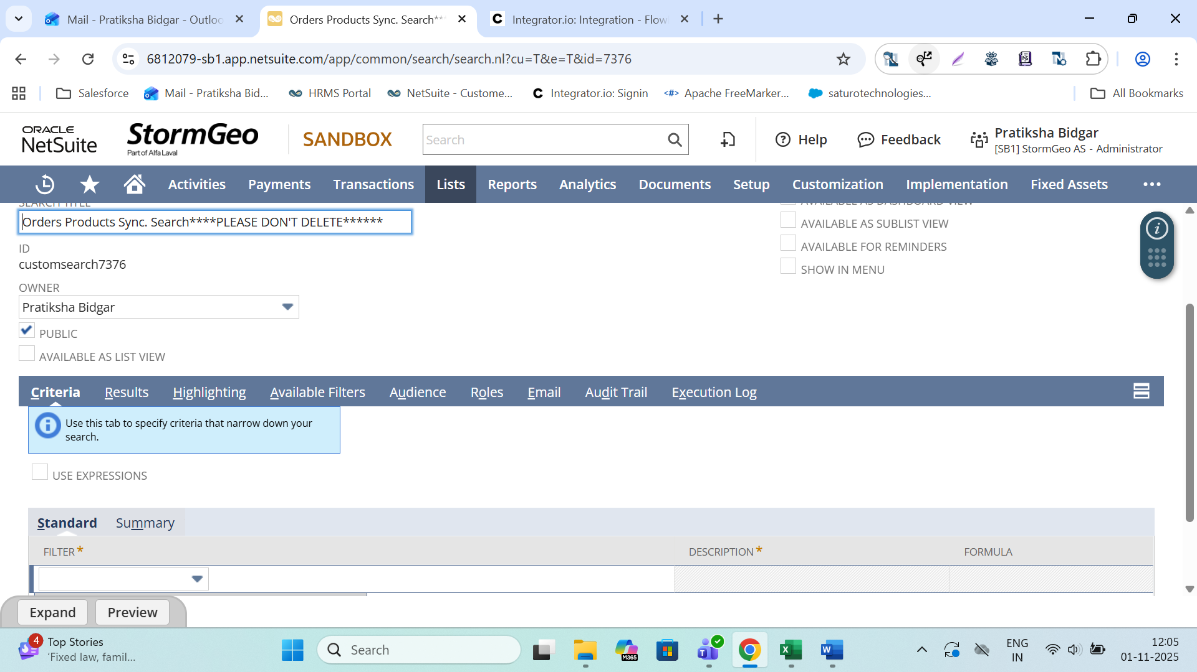
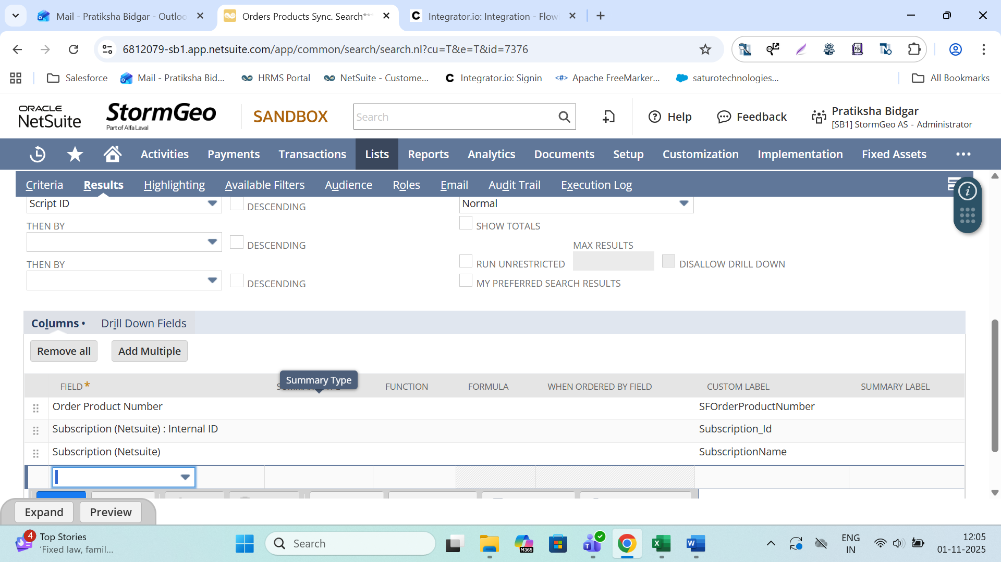

2.Subscription Line Search****PLEASE DON'T DELETE****
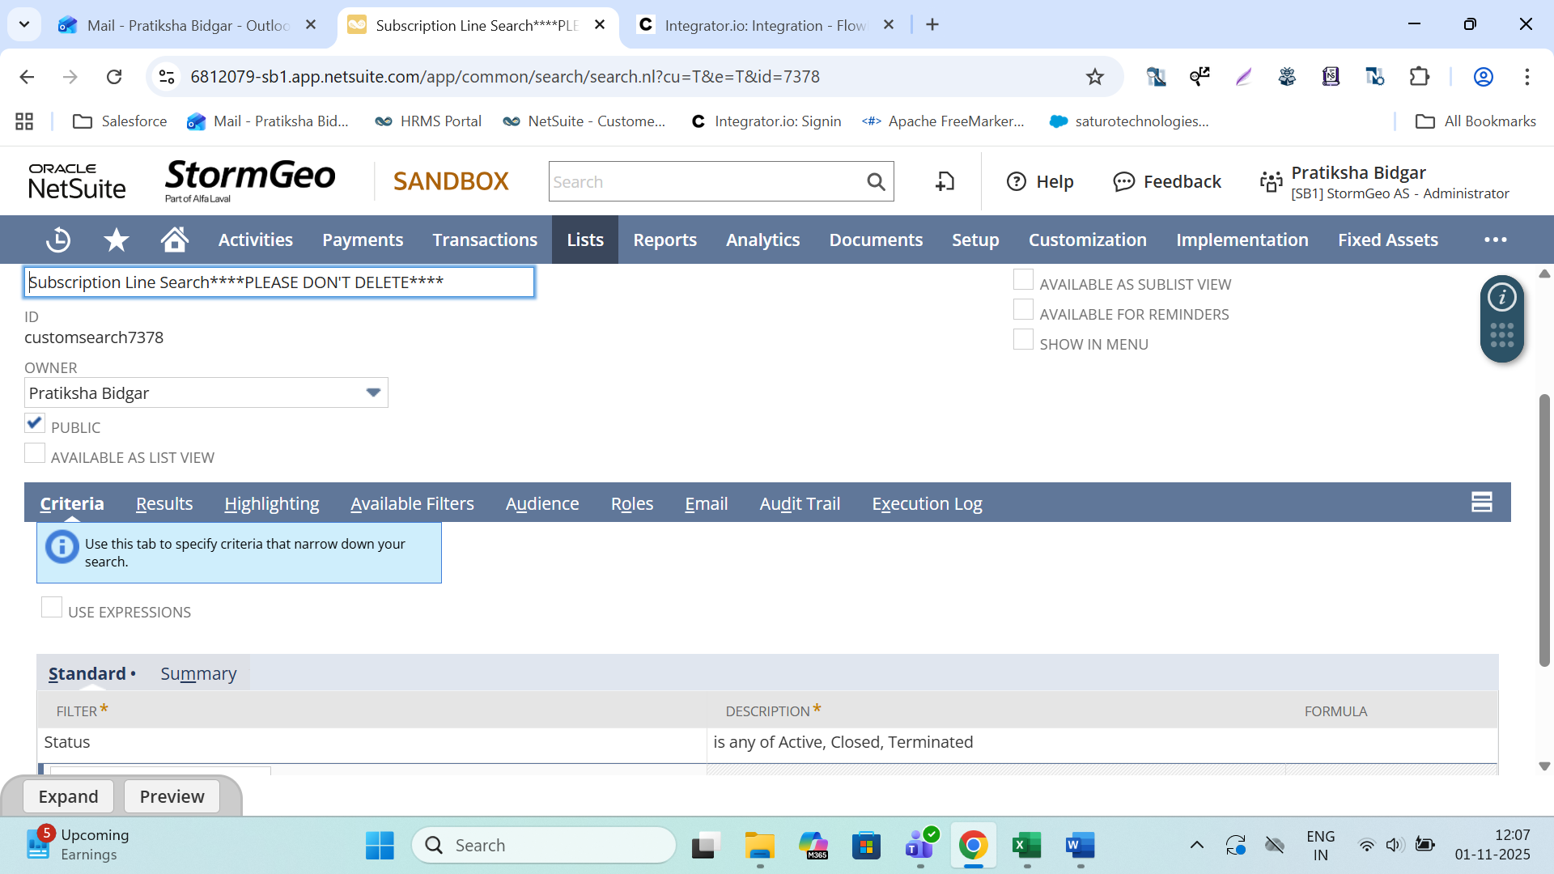
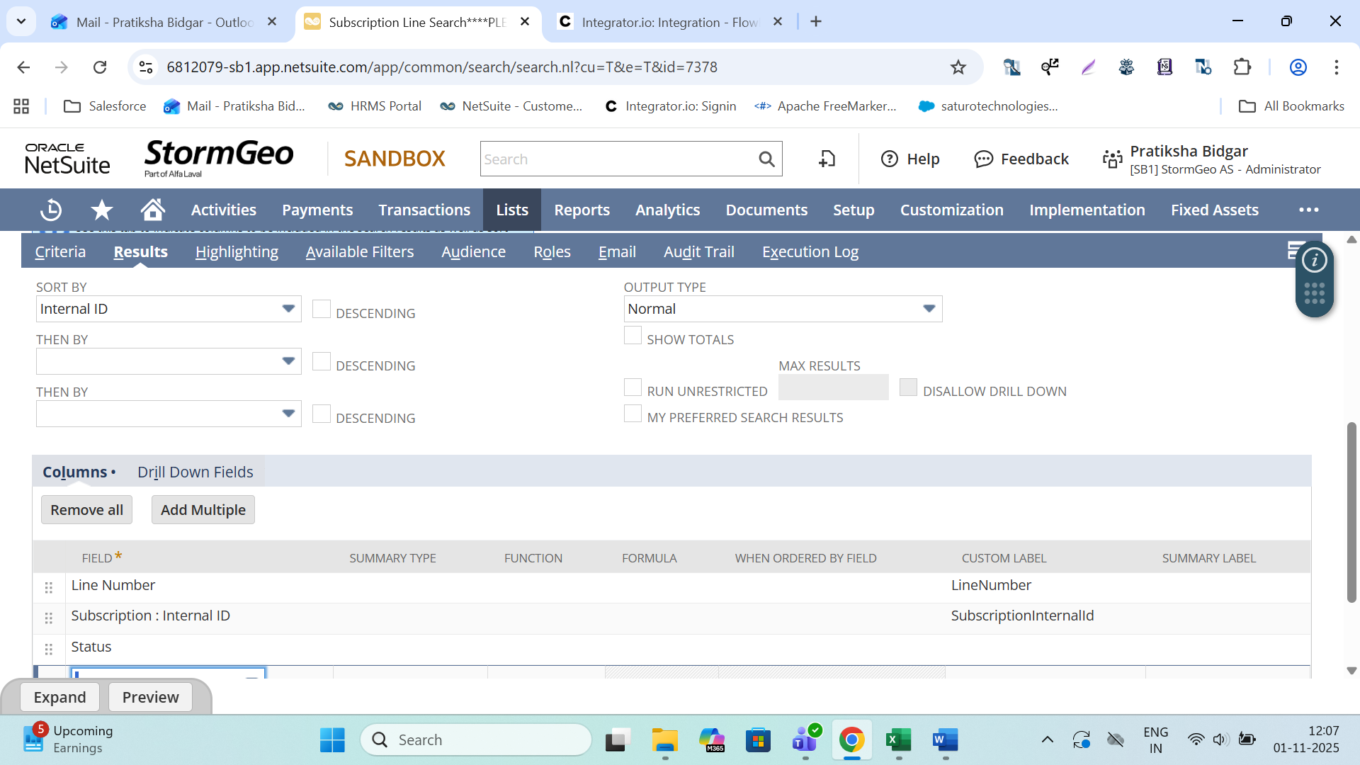
3.Mass Update
SAT | Usage void

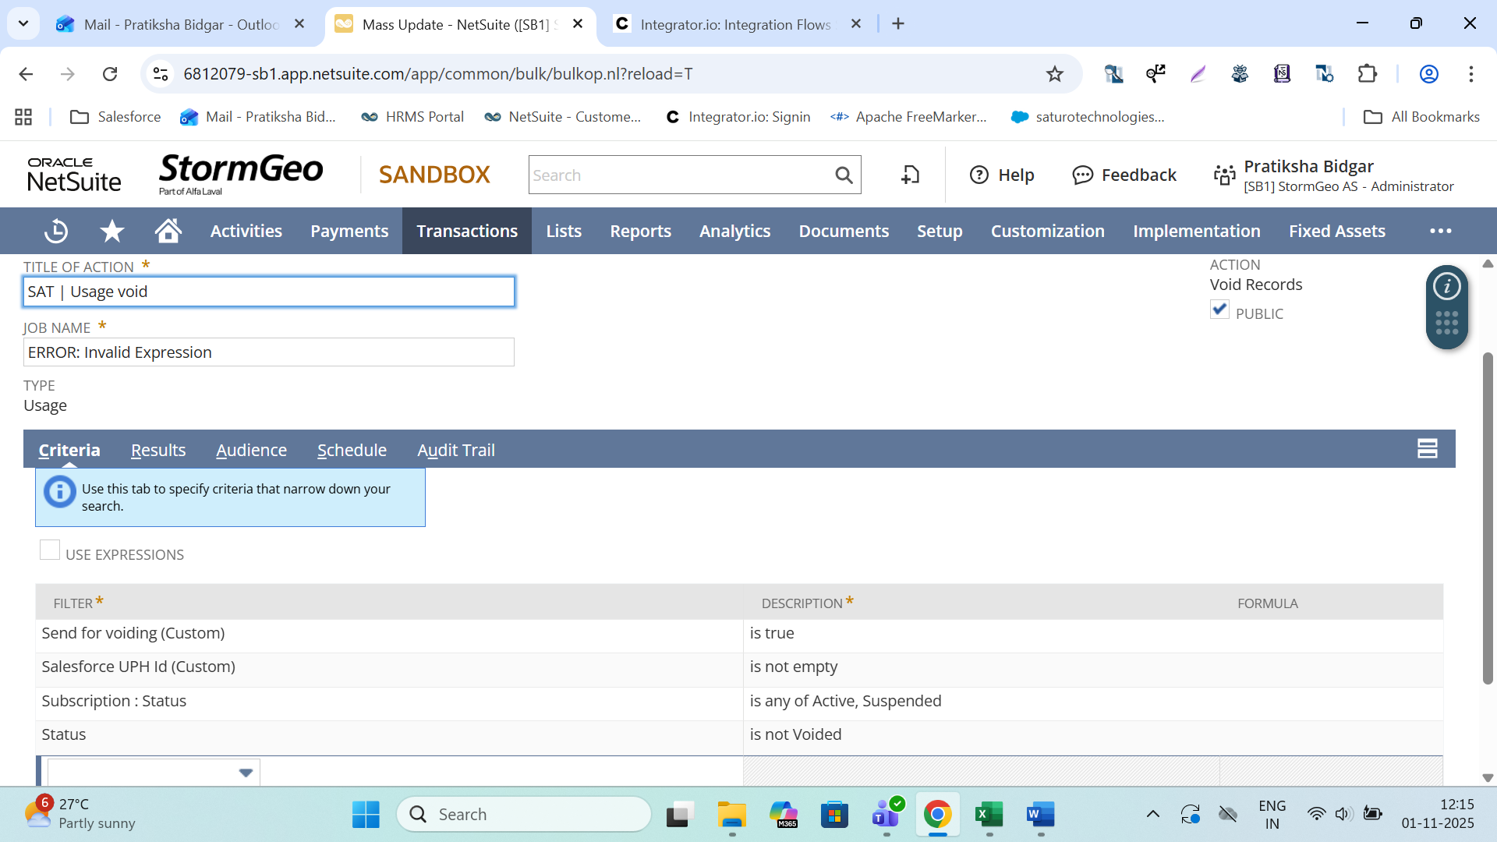
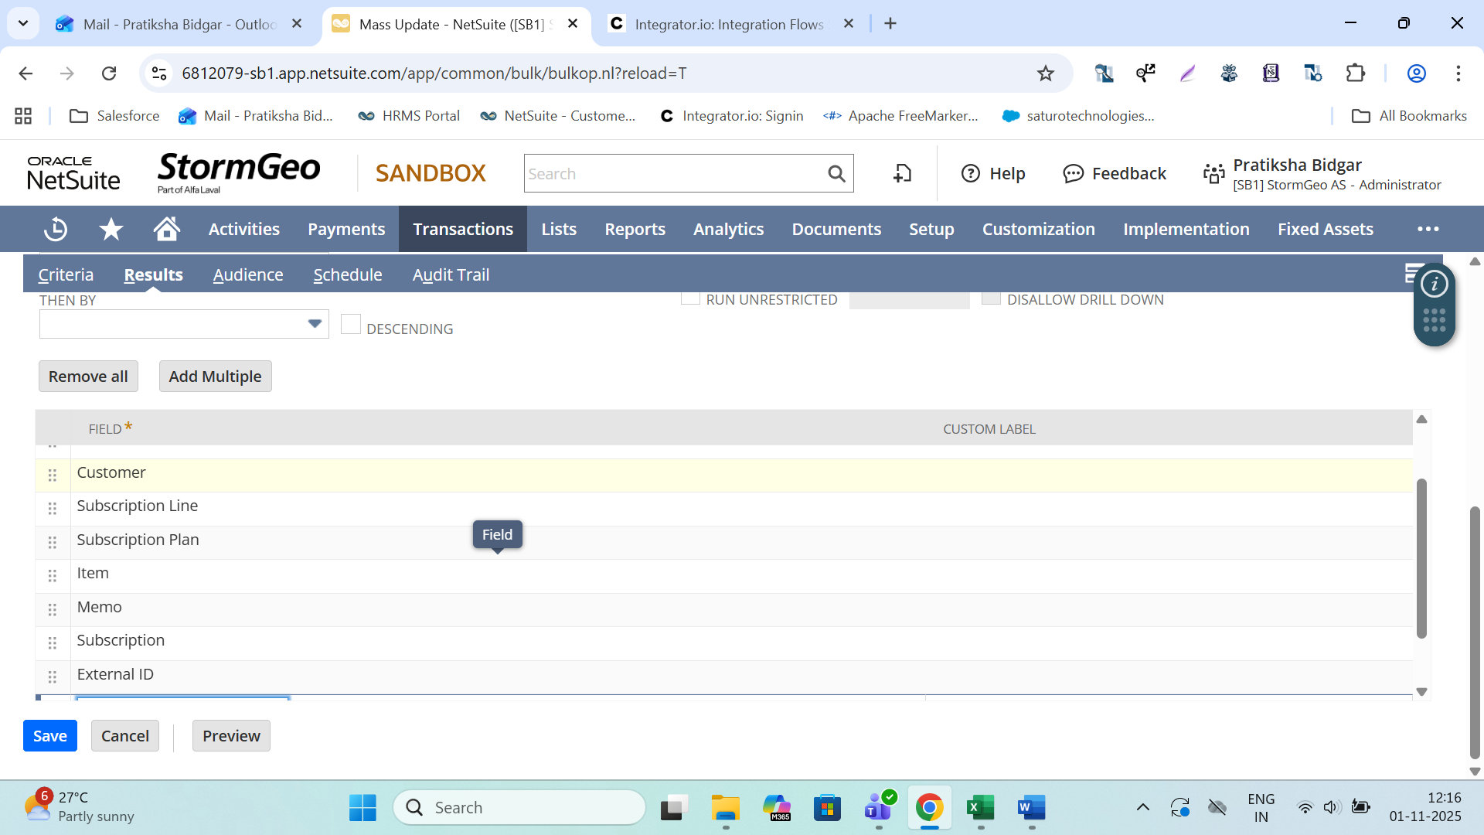

DF7:- Netsuite Usage Status Synch to Salesforce UPH
